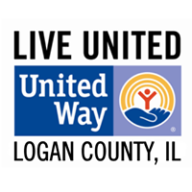
LIVING UNITED IN LOGAN COUNTY

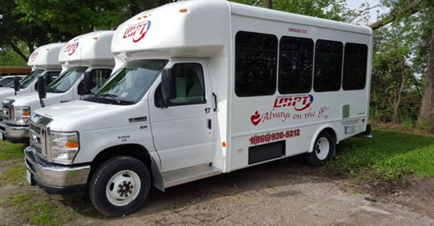

For 2020, The United Way of Logan County continues to partner with 15 non-profit programs in our community. CAPCIL Transit is one of those programs.
The CAPCIL Transit Program is a transportation program designed for seniors and disabled persons of Logan County, offering reliable on-demand transportation to and from medical appointments, socialization activities, retail establishments, and employment and volunteer opportunities. The program serves individuals aged 60 years and older who struggle with financial stability, while maintaining their independence.
Many transports have been provided to veterans needing to see doctors at the VA in Springfield and Peoria. Many of the transports have been for critical medical appointments, like dialysis, cancer treatments, and other critical medical needs, and some are for shopping or socialization. CAPCIL Transit also partners with local care facilities, including transportation to ALMH’s Senior Life Solutions Program. The suggested donation for a one way ride is $3.00 which does not cover the full cost of transportation. United Way funds are used to offset the difference in cost, to make sure that this service continues to be made available to our most vulnerable citizens.
Your Support Matters! Because this community supports The United Way of Logan County, Illinois, children have opportunities to live healthy, busy lives. Seniors can remain active and in their own homes. Families can prosper and recover from tragedy. Together we are doing what no one person or organization can do alone.
Thank you for making a difference.

