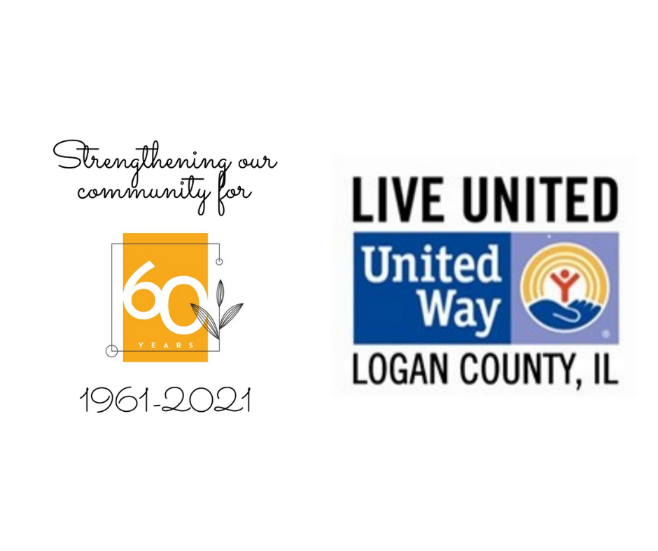
PRESS RELEASE – October 2, 2021
UNITED WAY OF LOGAN COUNTY CELEBRATES 60 YEARS OF STRENGTHENING OUR COMMUNITY IN 2021
On October 2, 1961, a group of Logan County community leaders including Walter Musick, Emil O. Stahlhut, Charles A. Purseglove, John T. McCullough and Marjorie B. Fuller were listed as the incorporators of the newly formed and incorporated United Fund of Lincoln.
The first United Fund Campaign was led in the fall of 1961 by Lewis C. Horton, and sought to raise $42,504 to support five agencies: The Boy Scouts, The Girl Scouts, The Red Cross, The Salvation Army and Logan County Mental Health. The campaign was launched in November of 1961 and $33,688 was raised locally toward the stated goal with the support of businesses, volunteers and individual contributors.
The United Fund became the United Way of Lincoln, and eventually the United Way of Logan County over the next 60 years. During this time, annual campaigns have raised and distributed millions of dollars, supporting non-profit organizations across the county, and helping thousands of Logan County residents live a better life.
In 2021, we look back on 60 years of strengthening this community. A lot has changed in 60 years. However, there are still those in our community who need assistance, and funds raised in Logan County still stay in Logan County. The United Way of Logan County will be raising funds once again in 2021 to continue partnering in 2022 with 14 local agencies and programs (including four of the original five agencies above), along with continuing to sponsor our 2-1-1 help line and the Dolly Parton Imagination Library for Logan County.
The United Way is still about communities coming together to help those in need. Your donation is an investment in Logan County youth, seniors and families, and works to strengthen our community, as donations have done to the United Way have done for the last 60 years.
Find out more about the work of the United Way of Logan County or give easily online at www.uwlogancountyil.org. You can also give by texting “Logancounty” to 313131.

